

SE112 – Introduction to Software Engineering

2024-2025 SPRING
Homework Project
Campus Navigation Application
Group 6
Merve Betül Parlakyiğit– 24244710020
Ilgın Yosun Sarı – 23244710062
Elif Öztürk –23244710078
Selim Toraman– 23244710026

Table of Contents
1. Project Proposal 1
2. Actors 2
3. Requirements 3
a) Functional Requirements 3
b) Non-Functional Requirements 3
4. Use Case Diagrams 4
5. Activity Diagrams 5
6. Sequence Diagrams 6
7. Class Diagram 7
8. Gantt Chart 8
9. Risk Management 9
a) Risks 9
b) B Plans 9
10. UI Design 10

Project Proposal
The aim of this project is to develop an Engineering Faculty Navigation Application that allows students and academic staff also the cleaning staff to easily find classrooms and offices on university campuses.
Unlike general navigation applications, this solution will be designed specifically for educational institutions and will provide real-time room status, shortest directions and class availability according to course schedules.
We picked agile methodology for our project and why it works best for us:
Agile methodology is a flexible and customer-focused methodology used in software and project management. Instead of traditional, rigid and prediction-oriented methods, it follows a process based on collaboration, iterative development and customer feedback to quickly adapt to uncertainty and transformation.
The advantages of the agile method are as follows:
- It adapts quickly to changing customer needs.
- It supports faster and more efficient completion of projects.
- It strengthens communication and collaboration within the team
- It allows for early detection and correction of errors
- It increases customer satisfaction.
Which will give us the flexibility to make adjustments.

Actors

- Student: Uses the app to find classrooms/laboratories / professors’-teaching assistansts’ officess ,check room status, and report issues.(Like when there is a room that is empty at the system but not empty in the real time , to inform other users. )

- Academic staff: Accesses office locations, updates room status (e.g., “vacant”), and views schedules. Also helpful for a novice academic.

- Administrator: Manages building/room data, verifies user notifications, and ensures system integrity, corrects bugs in the operation of the system .

- Cleaning Staff: Cleaning times are set by showing the empty classrooms and time is saved.( Cleaning hours can be rescheduled when a classroom is free to save time on staff work. And cleaning staff should send instant notifications to users using the system when a class is not available at the cleaning time.)

Requirements

Functional Requirements
Users can search for classes by building name or room number.

The app displays real-time room status (for example, “occupied” or “empty”).

Users can report incorrect room information or facility issues.

Integration with university programs displays classes in rooms.

Provides the shortest possible directions between two points on campus.

Displays basic map and room information in offline mode.

Users can save frequently used locations.

Sends push notifications for schedule changes or room changes.

Provides multilingual support for international users.

User notifications are managed and verified via the staff dashboard.

Non-Functional Requirements
The app should show directions within 2 seconds.
It should work with consistent performance on Android and iOS.
It should comply with data privacy rules (e.g., no leaking of personal schedule information).
It should be able to work on large campuses with 20 and more classrooms.
Accessible design (e.g., voice-over option for the visually impaired).

Use Case Diagrams
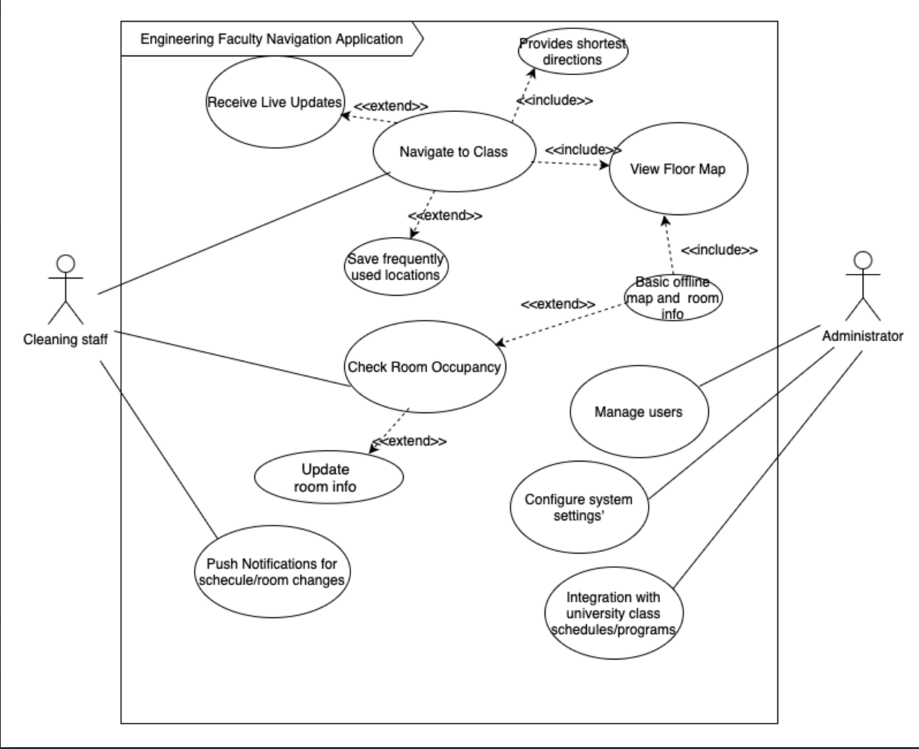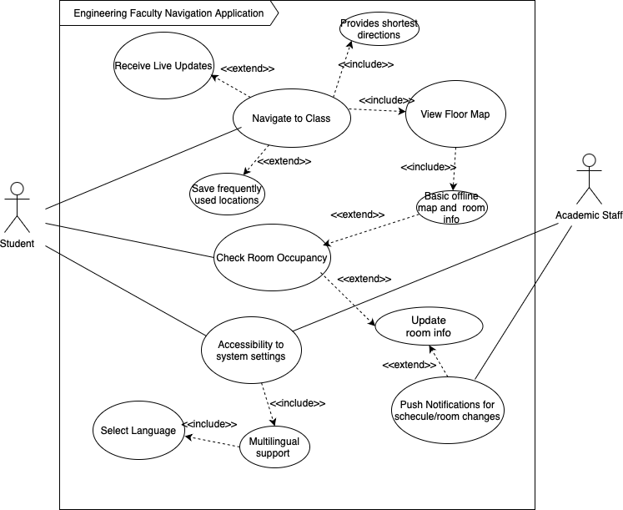

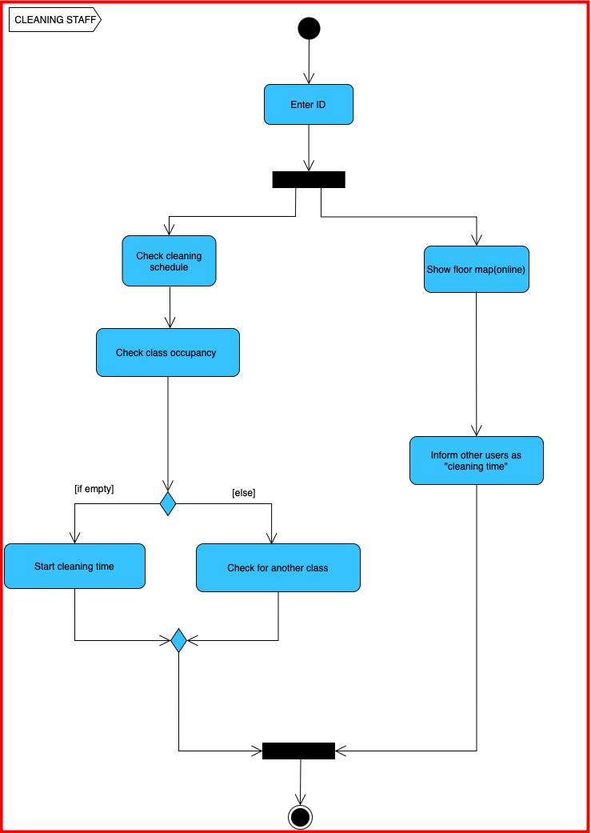
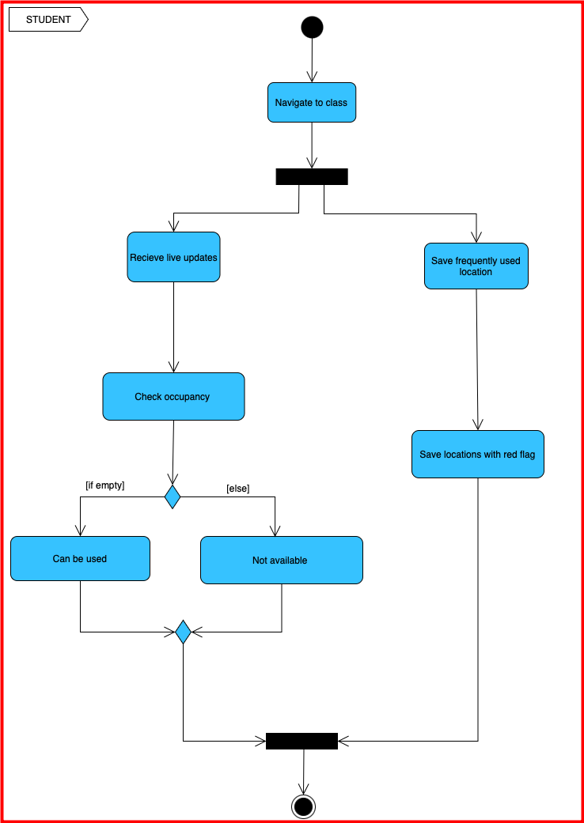
Activity Diagrams

Sequence Diagrams
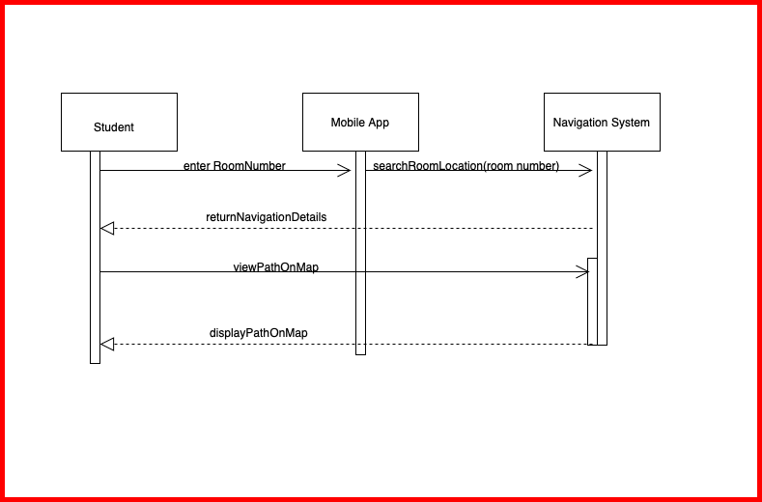

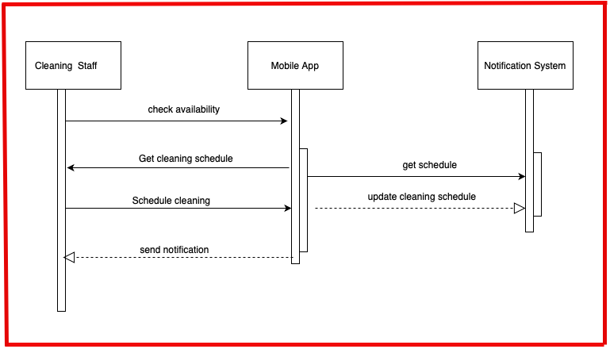

Class Diagram

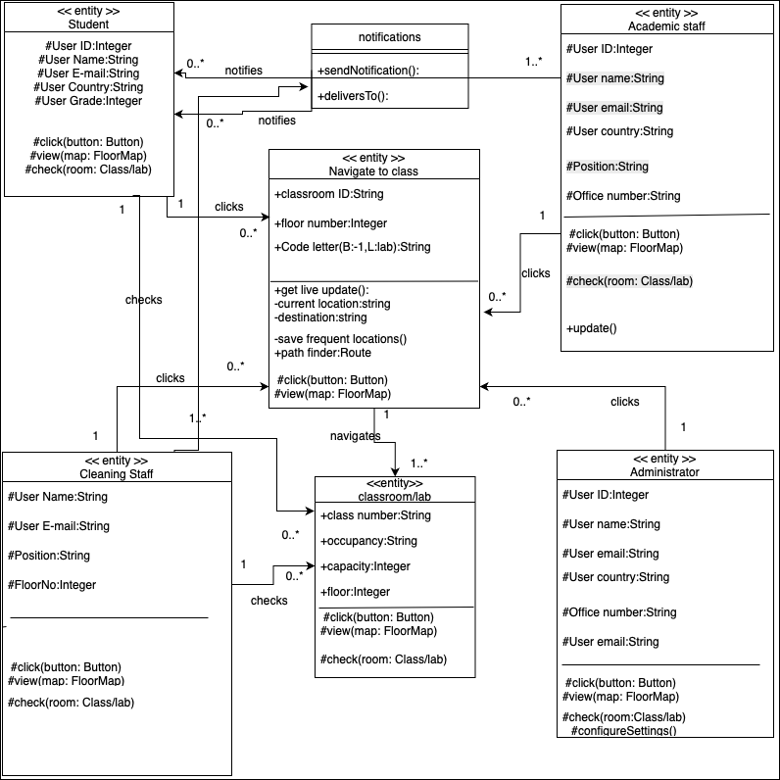

Gantt Chart
Project View Gantt Chart:

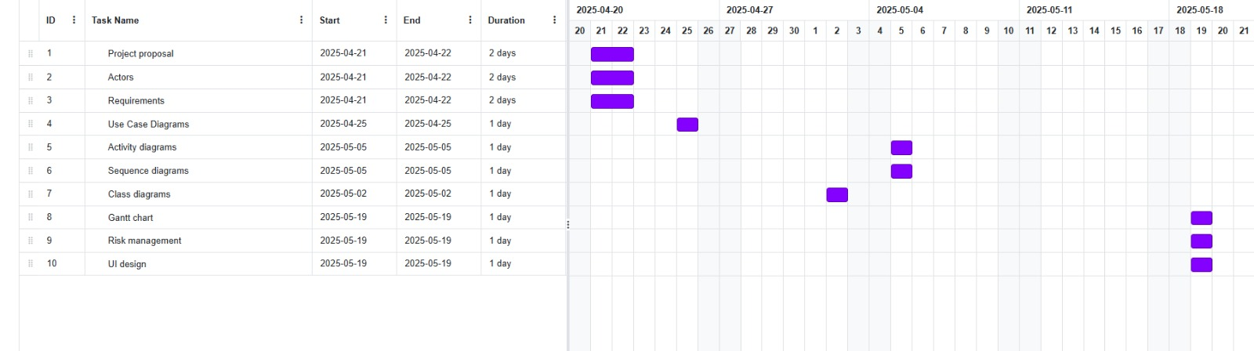

Resource View Gantt Chart:

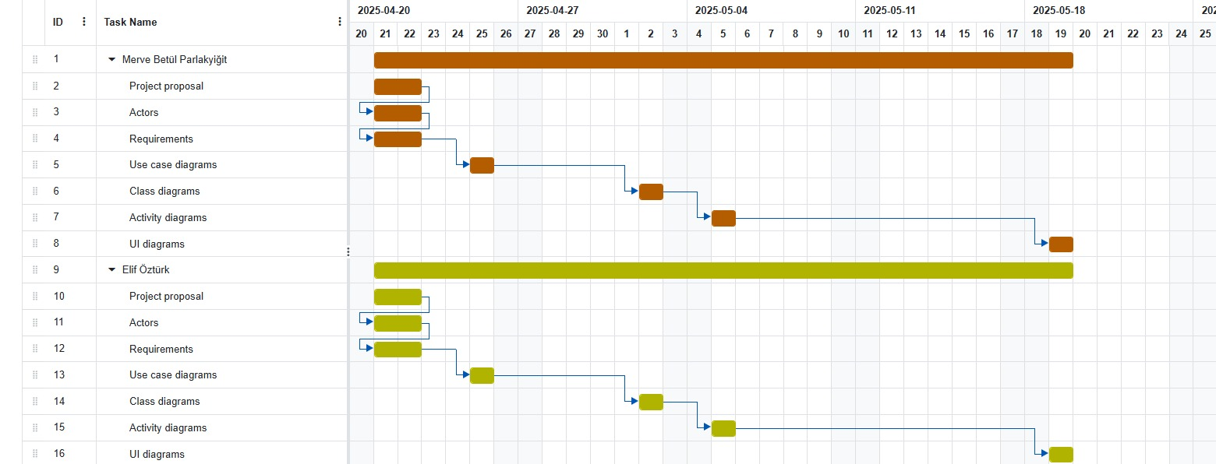

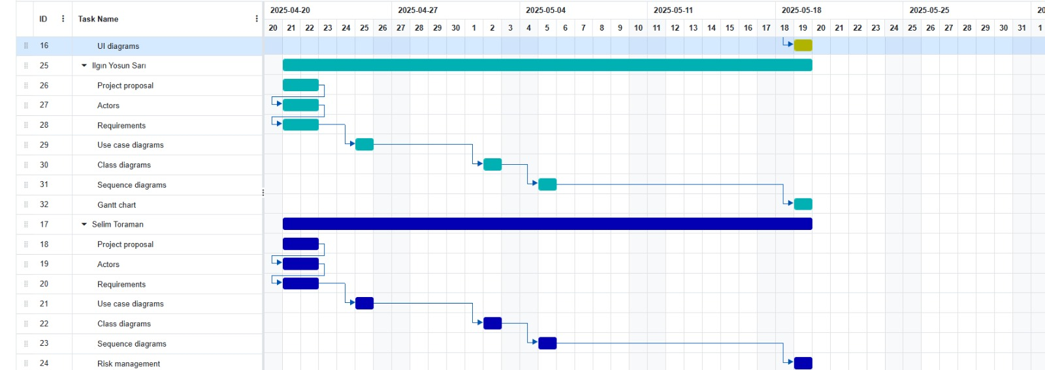

Risk Management

Risks
- Risk 1: One of the team members may not be able to dedicate enough time to the project due to the workload from other courses.

- Risk 2: If the university’s building map or classroom information is not provided on time, we may not be able to fully develop the navigation feature.

B Plans
- Plan B for Risk 1: We will clearly assign tasks from the beginning and hold regular meetings to track each member’s progress. This way, we can detect problems early and take action quickly.

- Plan B for Risk 2: Until we receive the actual map and classroom data, we will develop the app using sample (temporary) data. Once the real data is available, we can easily replace it. If necessary, we will contact the university administration to get the data more quickly.(As we use agile methodology we can make later adjustments to our application.)

UI Design
